**Parking Management System**

**(Use case Analysis)**

**Project Number**

Group No. 7

**Submitted To:**

Mam. Sadaf Naeem

**Project Team**

Abdur Rehman 231370155

Rehan Ahmad 231370156

Mahad Ahmad 231370157

**Submission Date**

15-Jan-2025

**Table of Contents**

**1.** **UCD** 3

**2.** **Use case Scenarios** 3

**3.** **Prototype** 5

**4.** **References** 7

# **UCD**

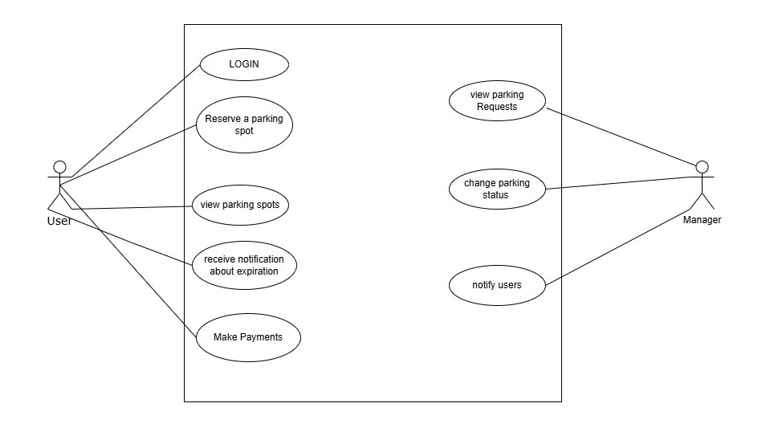

# **Use case Scenarios**

|  |  |
| --- | --- |
| UC ID | UC-01 |
| Name | Login |
| Actor | User |
|  |  |
| **Normal flow of events:** | |
| **Actor Actions** | **System Response** |
| 1. User enters ID. 2. User enters password. 3. User clicks on “Login” button. | 1. System validates credentials. 2. Displays message “success” 3. Redirect to home screen. |
| **Exceptions** |  |
| E01 | 1. Wrong Credentials. 2. System displays a message “Invalid Username/Password.”. |

|  |  |
| --- | --- |
| UC ID | UC-02 |
| Name | Reserve a parking spot |
| Pre-condition/ pre-state | User must log in.  User should be on form page |
| Post-condition/post-state | System has a new record  User should be able to reserve a spot. |
| **Normal flow of events:** | |
| **Actor Actions** | **System Response** |
| 1. User selects “city”. | 1. System fetches areas list from db. |
| 1. User clicks on dd menu. | 1. System displays a menu list |
| 1. User selects a suitable spot. | 1. System saves user selection. |
|  |  |
| **Exceptions** |  |
| E01 | 1. No data fetched from API. 2. System displays a message “No Data found”. |
| E02 | 1. Data not saved. 2. System displays a message “Data not saved”. |

|  |  |
| --- | --- |
| UC ID | UC-03 |
| Name | View Parking Spots |
| Pre-condition/ pre-state | User must log in.  User should be on form page |
| Post-condition/post-state | System has a new record  User should be able view parking spots. |
| **Normal flow of events:** | |
| **Actor Actions** | **System Response** |
| 1. User Selects a city. 2. User selects ‘see available spots’ option to view parking spots. | 1. System fetches data from DB. 2. System displays all the parking spots. |
| **Exceptions** |  |
| E01 | 1. Data not fetched. 2. System displays a message “No Data found”. |
| EO2 | 1. Wrong Parking spots displayed. |

|  |  |
| --- | --- |
| UC ID | UC-04 |
| Name | Change Parking Status |
| Actor | Manager |
|  |  |
| **Normal flow of events:** | |
| **Actor Actions** | **System Response** |
| 1. Manager changes parking status to ‘reserved’ when the user reserves a spot. 2. Manager changes parking status to ‘available’ when the time expires of parking. | 1. System saves the option. 2. System displays the status of parking to a user. |
| **Exceptions** |  |
| E01 | 1. Manager accidently changes status of a wrong parking spot. |
| EO2 | 1. System does not save the updated action. |

# **Prototype**

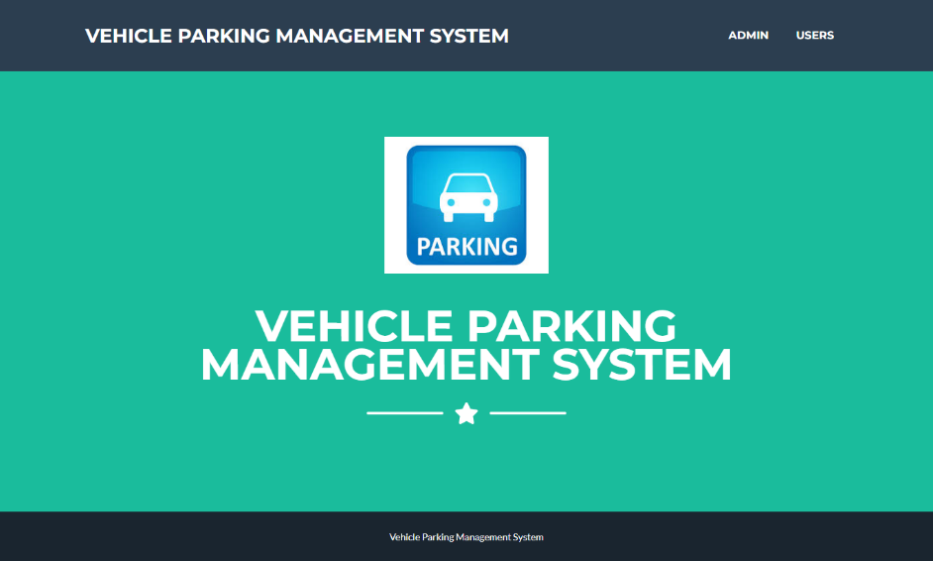

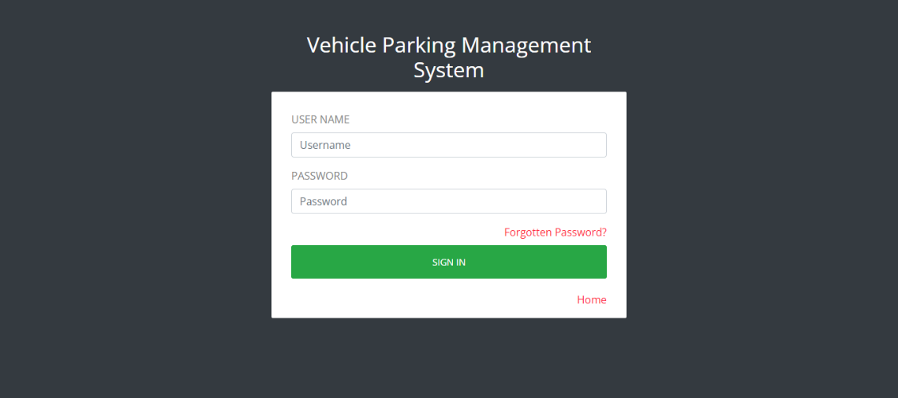

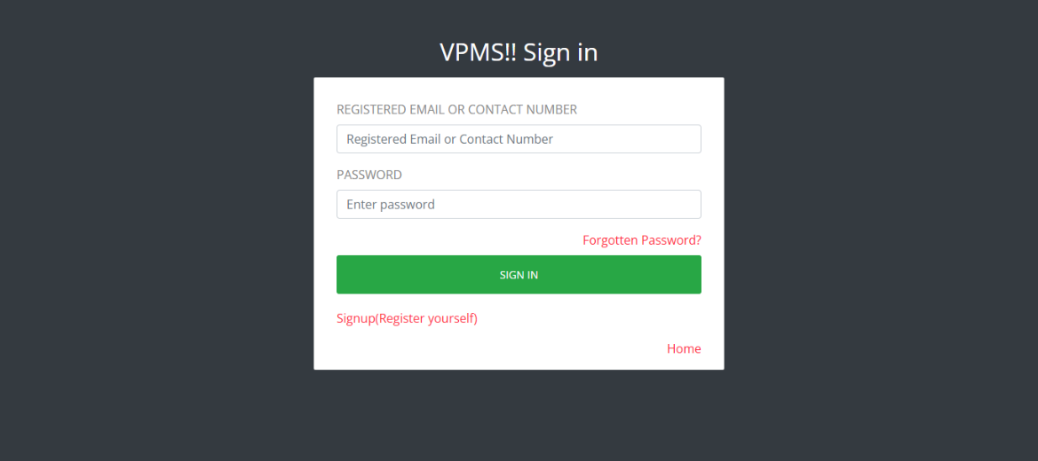

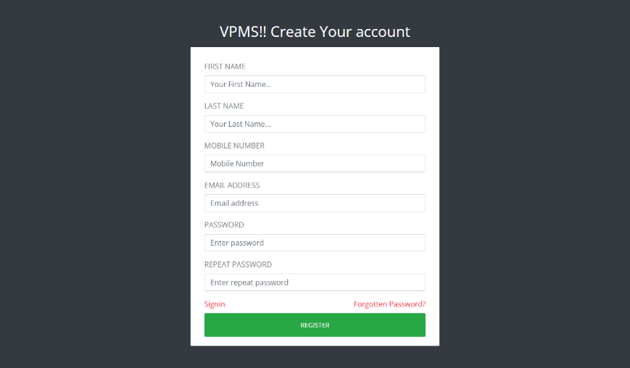

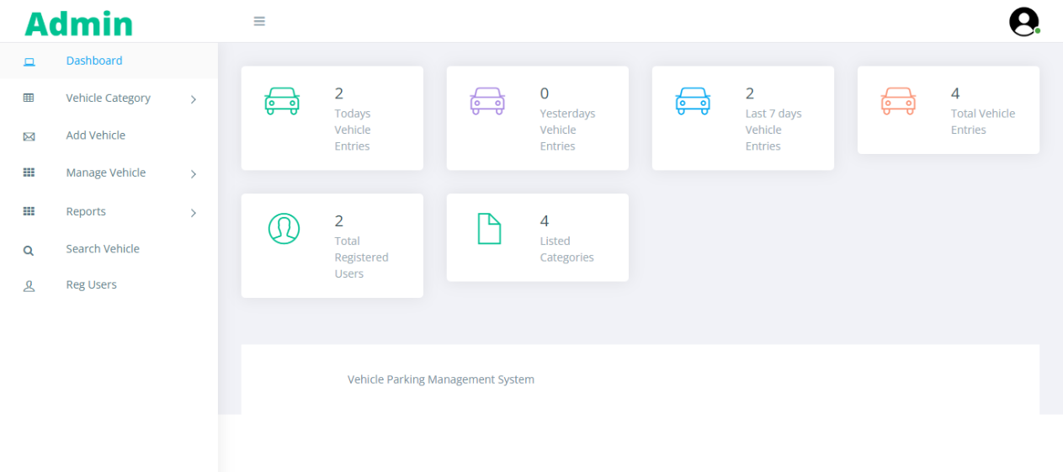

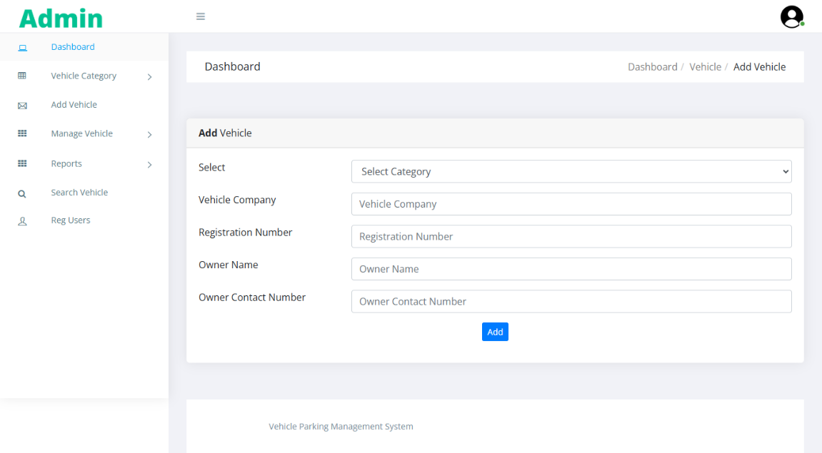

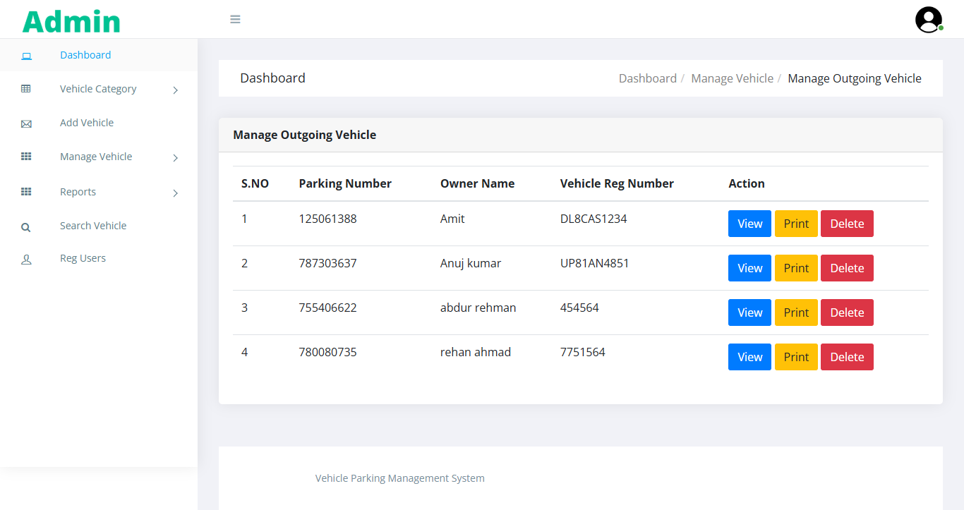

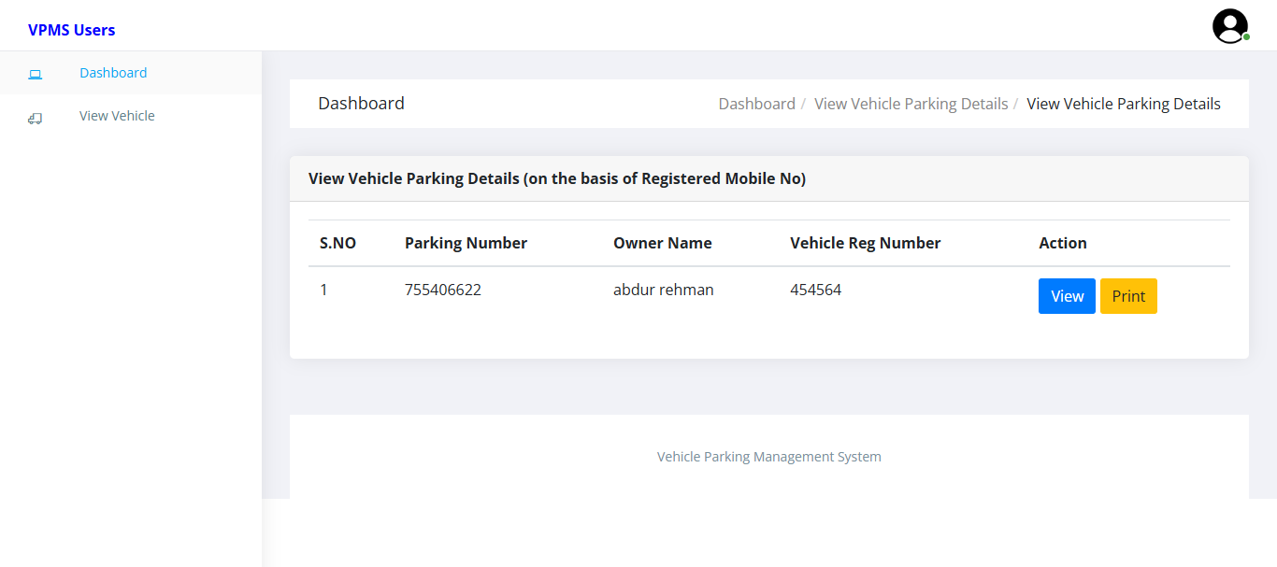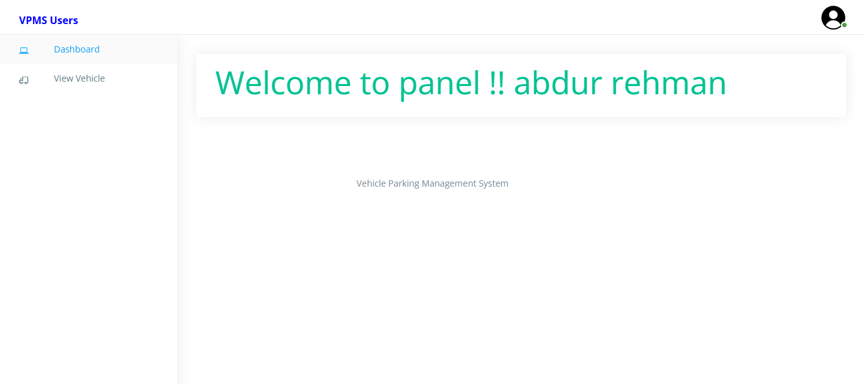

# **References**

R. S. Pressman, Software Engineering: A Practitioner’s Approach, 8th ed., McGraw-Hill

https://www.smartparking.com

**NOTE:**

1. References section should be on a last page.
2. The proposal should be prepared jointly by all the group members.